**23CSE111**

OOPS

**LAB MANUAL**

**Department of CSE**

**Amrita School of Engineering**

**Amrita Vishwa Vidyapeetham, Amaravati Campus**

**Verified By Name: B.Tirumala Sai**

**Roll No: 24028**

|  |  |  |  |  |
| --- | --- | --- | --- | --- |
| S.NO | Programs | Date | Pg:No | Signature |
| 1 | 1. Download and Install Java Software. 2. Write a java program to print message “Welcome to java programming”. 3. Write a java program that prints name,roll number,section of a student. |  |  |  |
|  |  |  |  |  |
|  |  |  |  |  |
|  |  |  |  |  |
|  |  |  |  |  |
|  |  |  |  |  |
|  |  |  |  |  |
|  |  |  |  |  |

Week-1

Program : 1

* Aim : Download and Install Java Software.
* Step 1 : Visit chrome and search “ java download”.And select Oracle website.

* Step 2 : Now open Oracle website scroll down and now select “JDK 21” for

Windows and select “X64 installer” and download it.

* Step 3 : After downloading open “this pc” in our laptop and open “program

files”,open “java”,open “JDK 21”

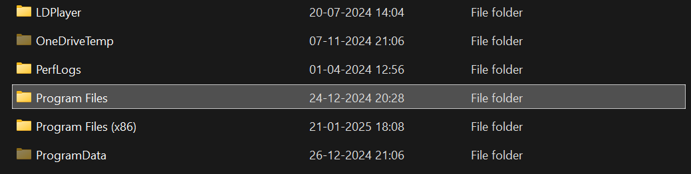

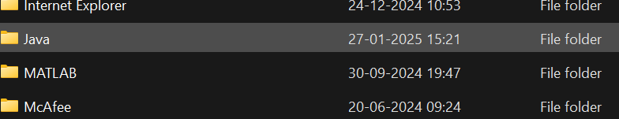 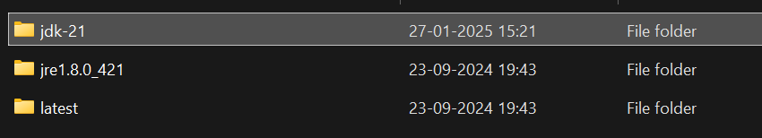

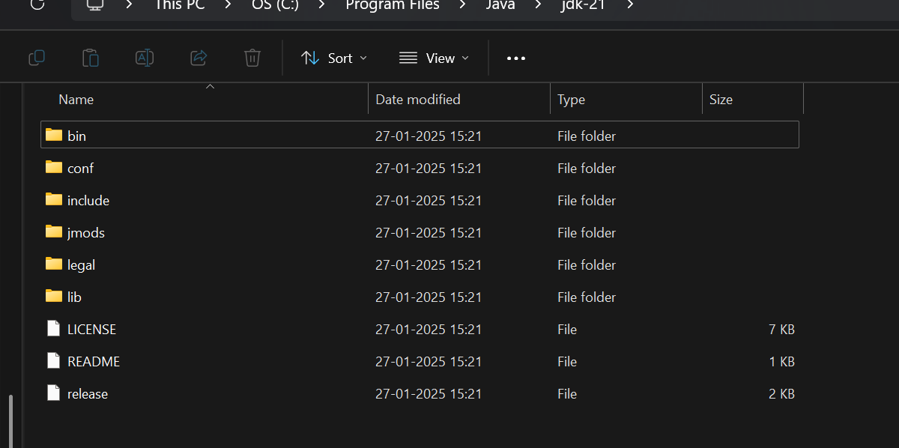

* Step 4 : In the task bar search and open “environment variables of system”,after opening environment variables, go to the system variables and see for java if there leave it. Or click path and add “JAVA” in ‘variable name’ and copy link in ‘variable value’

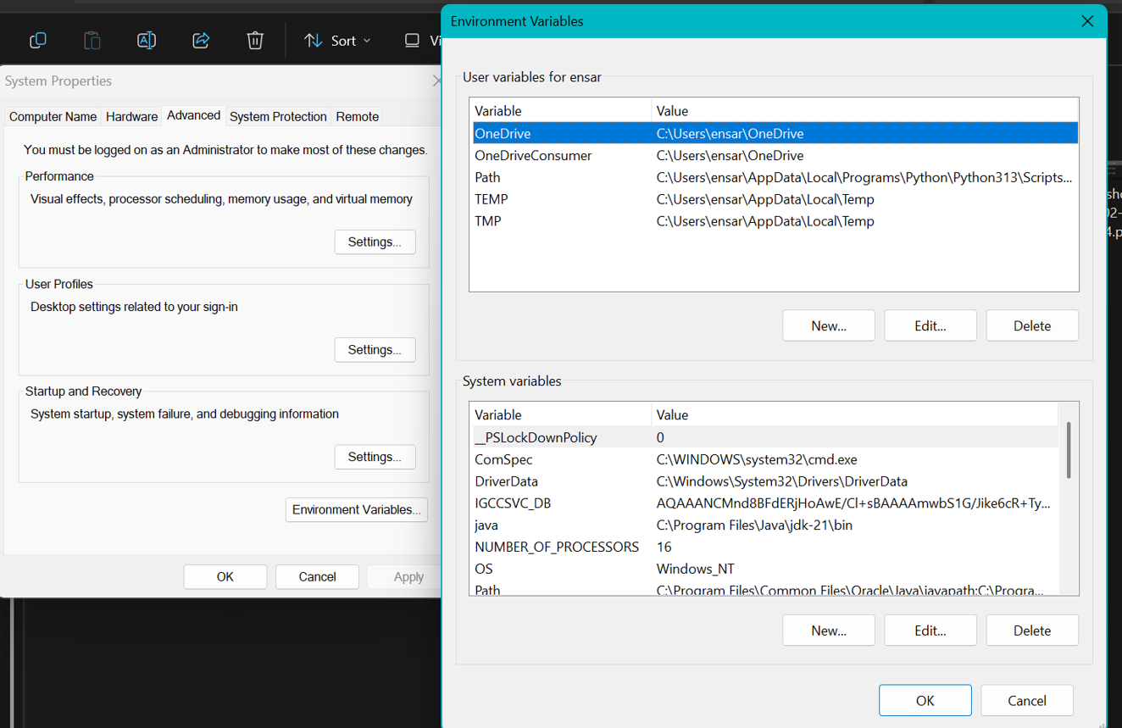

* Step 5 : Verifying Installation of Java. Again open task bar and search “cmd”,

open it ant type “java –version” and press enter. It will show the

version of installation of java.

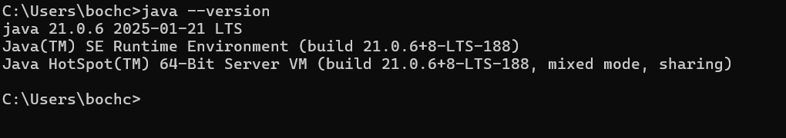

Successfully Java is installed and it will show the version otherwise it will show error and command is not recognized.

Program : 2

Q) Write a java program to print the message “welcome to java program”.

class Main{

public static void main(String[] args){

System.out.println("welcome to java programming");

}

}

OUTPUT

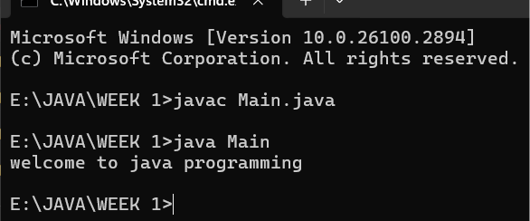

Program : 3

Q) Write a java program that prints name,roll number,section of a student.

public class my_profile{

public static void main(String[] arg){

System.out.println("name:B.Tirumala Sai");

System.out.println("sec:CSE-A");

System.out.println("Roll.no:24028");

}

}

OUTPUT

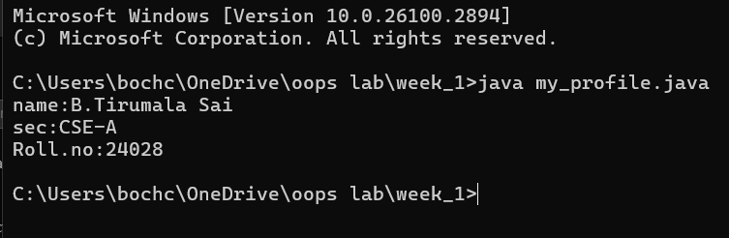

Week-2

Program : 1

import java.util.Scanner;

class rectangle{

public static void main(String[]args){

Scanner input=new Scanner(System.in);

System.out.println("enter the length");

int len=input.nextInt();

System.out.println("enter the bredth");

int bred=input.nextInt();

int area=len*bred;

System.out.println(area);

}}

OUTPUT: 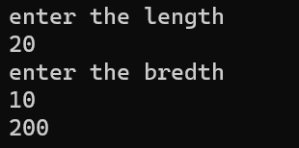

|  |  |  |
| --- | --- | --- |
| s.no | EXPECTED ERROR | REASON |
| 1. | ; | **; is expected at end** |
| 2. | AREA | Declaration of int type variable |

Program : 2

import java.util.Scanner;

class tem{

public static void main(String[]args){

Scanner input =new Scanner(System.in);

System.out.println("enter the the temperature in degrees:");

double deg=input.nextDouble();

System.out.println("the temperature in fahrenheit"+((deg*9/5)+32));

}

}

OUTPUT: 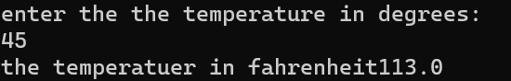

ERRORS:

|  |  |  |
| --- | --- | --- |
| S.No | EXPECTED ERROR | REASON |
| 1. | ; | ;expected at end |
| 2. | Input().close | The input is expected to closed |

Program : 3

import java.util.Scanner;

class simpleintrest{

public static void main(String[]args){

Scanner input=new Scanner(System.in);

System.out.println("enter the p value");

int p=input.nextInt();

System.out.println("enter the t value");

int t=input.nextInt();

System.out.println("enter the r value");

int r=input.nextInt();

float si=(p*t*r)/100;

System.out.println(si);

}

}

OUTPUT: 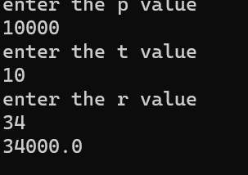

|  |  |  |
| --- | --- | --- |
| S.No | EXPECTED ERROR | REASON |
| 1. | ; | ; is expected at end |
| 2. | Int t | **Without declaring t the compiler cannot execute the program.** |

Program : 4

import java.util.Scanner;

class largest{

public static void main(String[]args){

Scanner input=new Scanner(System.in);

System.out.println("enter value of A");

int a=input.nextInt();

System.out.println("enter value of B");

int b=input.nextInt();

System.out.println("enter value of C");

int c=input.nextInt();

int large=(a>b)?((a>c)?a:c):((b>c)?b:c);

System.out.println(large);

}

}

OUTPUT:

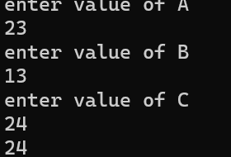

ERRORS:

|  |  |  |
| --- | --- | --- |
| S.No | EXPECTED ERROR | REASON |
| 1. | ? | Checks the condition |
| 2. | : | Comparing between two variables |

Program : 5

import java.util.Scanner;

class factorial{

public static void main(String[]args){

Scanner input=new Scanner(System.in);

System.out.println("enter the number to find its factorial");

int n=input.nextInt();

int sum=1;

for(int i=1;i<=n;i++){

sum=sum*i;}

System.out.println(sum);

}

}

OUTPUT: 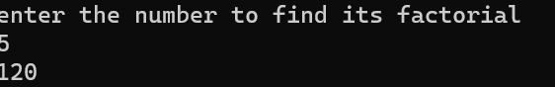

ERRORS:

|  |  |  |
| --- | --- | --- |
| S.No | EXPECTEED ERRORS | REASON |
| 1. | } | To close for loop |
| 2. | ; | ; expected |

Week-3

Program : 1

Q) **Write a java program with the following instructions**.

1. Create a class with name car.
2. Create four attributes named car_colour,car_brand,fuel_type,top_speed.
3. Create three method named “Start_Racing”,”End_Race”.{ }
4. Create three objects named Car1,Car2,Car3.
5. Create a constructor which should print “Welcome to Garage”.

Class Diagram:

|  |
| --- |
| **Car** |
| * carColor: String |
| * carBrand: String |
| * fuelType: String |
| * topSpeed: int |
| + Car(String,String,String,int) |
| + startRacing() |
| + endRace() |

public class Car {

private String carColour;

private String carBrand;

private String fuelType;

private int topSpeed;

public Car(String carColour, String carBrand, String fuelType, int topSpeed) {

this.carColour = carColour;

this.carBrand = carBrand;

this.fuelType = fuelType;

this.topSpeed = topSpeed;

System.out.println("Welcome to car garage");

}

public void startRacing() {

System.out.println(carBrand + " (" + carColour + ") is starting the race with a top speed of " + topSpeed + " km/h and runs on " + fuelType + "!");

}

public void endRace() {

System.out.println(carBrand + " (" + carColour + ") has finished the race!");

}

public static void main(String[] args) {

// Creating three objects

Car car1 = new Car("Red", "Ferrari", "Petrol", 200);

Car car2 = new Car("Blue", "Tesla", "Electric", 250);

Car car3 = new Car("Black", "BMW", "Diesel", 220);

car1.startRacing();

car1.endRace();

car2.startRacing();

car2.endRace();

car3.startRacing();

car3.endRace();

}

}

Output:

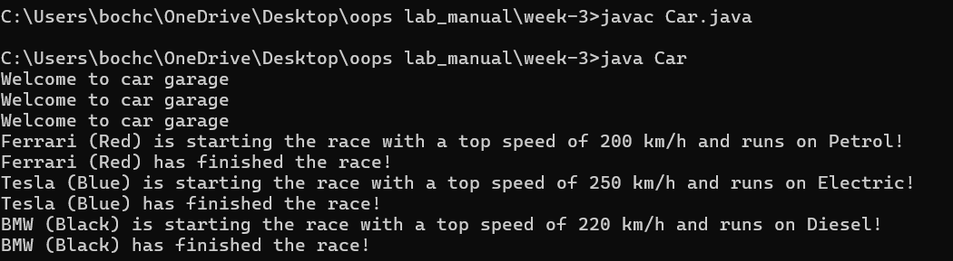

|  |  |  |
| --- | --- | --- |
| **S.NO** | **Errors** | **Rectification** |
| 1 | } | To close for loop |
| 2 | System.out.print(); | If we place the print statement inside the for loop it will print the each i value everytime but to print only the final value we must place it outside the for loop. |

* Program : 2

Q ) Write a class by writing java program named Bank Account

with two methods “deposits and withdraw”.

a) In deposit method whenever an amount is deposited it

has to be updated with current amount (logic C.A+D.A).

b) With draw amount whenever an amount is being

withdraw it has to be less than the current amount less

than the amount else print “Insufficient funds”.

Class Diagram:

|  |
| --- |
| Bank Account |
| * currentAmount: double |
| + BankAccount(initialAmount:double) |
| + deposit(amount: double):void |
| + withdraw(amount: double):void |
| + getCurrentAmount():double |

import java.util.Scanner;

class BankAccount {

String name;

int accountNumber;

int currentBalance;

BankAccount(String name, int accountNumber, int currentBalance) {

this.name = name;

this.accountNumber = accountNumber;

this.currentBalance = currentBalance;

System.out.println("Customer Details: " + name + ", Account Number: " + accountNumber + ", Current Balance: " + currentBalance);

}

public void withdraw(int withdrawAmount) {

if (withdrawAmount <= currentBalance) {

currentBalance -= withdrawAmount;

System.out.println("Withdrawn: " + withdrawAmount);

System.out.println("Current Balance: " + currentBalance);

} else {

System.out.println("Insufficient Funds");

}

}

public int deposit(int depositAmount) {

currentBalance += depositAmount;

System.out.println("Deposited: " + depositAmount);

return currentBalance;

}

public static void main(String[] args) {

Scanner scanner = new Scanner(System.in);

System.out.print("Enter your name: ");

String name = scanner.nextLine();

System.out.print("Enter your account number: ");

int accountNumber = scanner.nextInt();

System.out.print("Enter your initial balance: ");

int initialBalance = scanner.nextInt();

BankAccount account = new BankAccount(name, accountNumber, initialBalance);

System.out.print("Enter amount to withdraw: ");

int withdrawAmount = scanner.nextInt();

account.withdraw(withdrawAmount);

System.out.print("Enter amount to deposit: ");

int depositAmount = scanner.nextInt();

account.deposit(depositAmount);

System.out.println("Final Amount: " + account.currentBalance);

scanner.close();

}

}

Output:

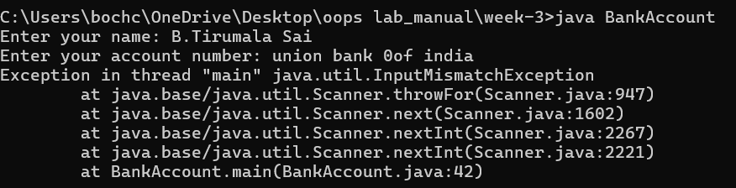

|  |  |  |
| --- | --- | --- |
| **S.NO** | **Errors** | **Rectification** |
| 1 | ; | ; is expected at end |
| 2 | Int t | Without declaring the compiler cannot execute the  program. |

Week-4

1)AIM: WRITE A JAVA PROGRAM WITH CLASS NAMED “Book”. THE CLASS SHOUKD CONTAIN VARIOUS ATTRIBUTES SUCH AS TITLE, AUTHOR, YEAR OF PUBLICATION. IT SHOULD ALSO CONTAIN A CONSTRUCTOR WITH PARAMETERS WHICH INITIALIZES TITLE, AUTHOR, YEAR OF PUBLICATION AND CREATE A METHOD WHICH DISPLAYS THE DETAILS OF 2 BOOKS.

PROGRAM-1:

class book

{

public String Title;

public String Author;

public int YearofPublication;

book(String Title, String Author,int YearofPublication)

{

this.Title=Title;

this.Author=Author;

this.YearofPublication= YearofPublication;

}

public void Details()

{

System.out.println("Title of the book:"+Title);

System.out.println("Author of the book:"+Author);

System.out.println("Year of Publication of the book:"+YearofPublication);

}

public static void main(String args[])

{

book b1=new book("JAVA Programming Language", "Dr.Suresh",2020);

b1.Details() ;

book b2=new book("Physics", "Dr.Sujata",2009);

b2.Details();

}

}

OUTPUT:

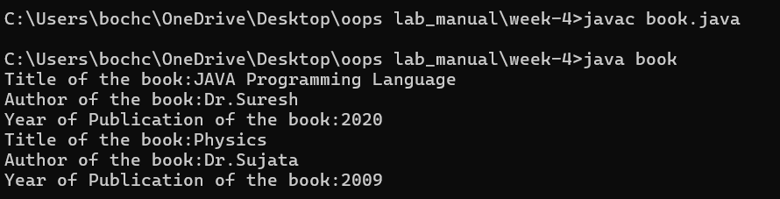

ERROR TABLE:

|  |  |  |  |  |
| --- | --- | --- | --- | --- |
| **Error Type** | |  | | --- | | **Incorrect Code** |  |  | | --- | |  | | **Corrected Code** |
| **Class Name Capitalization** | public class book | public class Book (Java follows PascalCase for class names) |
| **Constructor Name Mismatch** | new book(...) | new Book(...) (Constructor name must match class name) |

CLASS DIAGRAM:

|  |
| --- |
| **Book** |
| - title: String  - author: String  - yearOfPublication: int |
| + Book(title: String, author: String, yearOfPublication: int)  + displayDetails(): void |

IMPORTANT POINTS:

1. Constructor:

• The constructor Book(String, String, int) is used to initialize the object when it is created.

• The keyword this is used to differentiate between class attributes and constructor parameters.

2.Method:

• The method displayDetails() is used to display the book details.

• The System.out.println() method prints the details to the console.

3. Object Creation:

• Two objects b1 and b2 are created using the constructor.

2)AIM: WRITE A JAVA PROGRAM WITH CLASS NAMED “MyClass” WITH A STATIC VARIABLE COUNT OF INT TYPE. INTIALIZE IT TO ZERO AND A CONSTANT VARIABLE “Pi” OF TYPE DOUBLE INITIALIZED TO “3.14” AS ATTRIBUTES OF THAT CLASS. NOW DEFINE A CONSTRUCTOR FOR “MyClass”, THAT INCREMENTS THE COUNT VARIABLE EACH TIME AN OBJECT OF “MyClass” IS CREATED. FINALLY, PRINT THE FINAL VALUES OF ‘COUNT’ AND ‘PI’ VARIABLES AND CREATE 3 OBJECTS.

PROGRAM:

public class MyClass {

static int count = 0;

static final double pi = 3.14;

MyClass() {

count++;

}

public static void main(String[] args) {

MyClass obj1 = new MyClass();

MyClass obj2 = new MyClass();

MyClass obj3 = new MyClass();

System.out.println("Count: " +count);

System.out.println("Pi: " +pi);

}

}

OUTPUT:

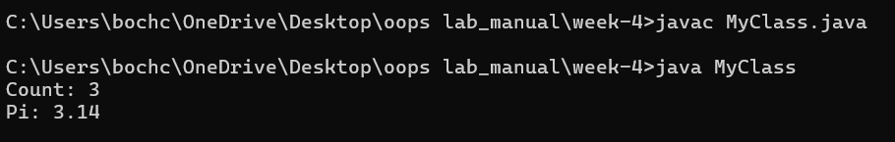

ERROR TABLE:

|  |  |  |
| --- | --- | --- |
| **Error Type** | **Incorrect Code** | **Corrected Code** |
| **Attempt to Modify final Variable** | pi = 3.14; (if added inside the constructor or method) | Remove this line (final variables cannot be reassigned) |
| **Incorrect Class Name** | public class Myclass | public class MyClass (Java follows PascalCase for class names) |

CLASS DIAGRAM:

|  |
| --- |
| **MyClass** |
| - Count: int  + pi: double |
| + MyClass()  + getCount(): int |

IMPORTANT POINTS:

1.Static Keyword

• Static members belong to the class, not to individual objects.

• Only one copy of the static variable is maintained for all objects.

2.Static Variable

• static int count:

o Shared among all objects of the class.

o It is initialized only once and not for every object.

o It increments every time the constructor is called.

3.Final Variable

• static final double pi:

o The final keyword makes the variable constant.

o Its value cannot be changed once assigned.

o It must be initialized at the time of declaration.

WEEK-5

Program : 1

Q)  **Create a calculator using the operations including addition using subtraction**

**multiplication and division using multilateral inheritance and display thr desired output.**

**Program:**

class bcalc {

int a, b;

int sum, diff;

bcalc(int a, int b) {

this.a = a;

this.b = b;

}

public void add()

{ diff = a - b;

sum = a + b;

System.out.println("Difference: " + diff);

System.out.println("Sum: " + sum);

}

}

class acalc extends bcalc {

int mul; acalc(int a, int b) {

super(a, b);

}

public void mult() {

mul = a * b;

System.out.println("Multiplication: " + mul);

}

}

class aacalc extends acalc {

float div;

aacalc(int a, int b) {

super(a, b);

}

public void divi()

{

if (b != 0) { // Check to avoid division by zero

div = (float) a / b;

System.out.println("Division: " + div);

}

else {

System.out.println("Division by zero error!");

}

}

}

class ocalc {

public static void main(String[] args) {

aacalc c = new aacalc(10, 2);

c.divi();

c.mult();

c.add();

}

}

Output:

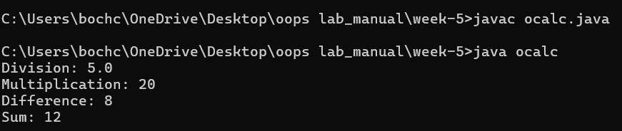

Class Diagram:

|  |
| --- |
| **Basic Operations** |
| + add (a,b)  +subtract (a,b) |

|  |
| --- |
| **Multiplication** |
| +Multiply (a,b) |

|  |
| --- |
| **Division** |
| + Divide (a,b) |

|  |  |
| --- | --- |
| **Subtraction** | |
| + subtraction(a,b) | |
|  | |  | |

|  |
| --- |
| **Calculator** |
| +calculate (op,a,b) |

ERROR TABLE:

|  |  |  |
| --- | --- | --- |
| **S.NO** | **Errors** | **Rectification** |
| 1 | .variable | We must mention variable name to call the variable. |
| 2 | static | Static variables contain only one value. |

Program 2:

Q)  **A Vechile rental company wants to develop a system ,that maintains information about**

**different types of vehicles available for rent.The company rents out cars and bikes and**

**they a need a program to store details about each vehicle such as brand and speed .**

* **Cars should have an additional properties .**
* **“Number of doors “ seating capacity.**
* **Bikes should have a property indicating whether they have gears are not ?**
* **The system should also include a fuction to display details about each vehicle and indicate when a vechicle is starting .**
* **If the company describes to add a new type of vechile ‘truck’ how would you modify above program.**
* **Truck should include an addition property capacity ‘in tons’.**
* **Create a show truck details method to display the trucks capacity.**
* **Write a constructor for truck that initializes all properties.**
* **Implement the truck class and update the main method to create a truck object and also create an object and also create an object car and bike subclass find display it details.**

PROGRAM:

class Vehicle {

protected String brand;

protected int speed;

public Vehicle(String brand, int speed) {

this.brand = brand;

this.speed = speed;

}

public void start() {

System.out.println(brand + " is starting.");

}

public void displayDetails() {

System.out.println("Brand: " + brand);

System.out.println("Speed: " + speed + " km/h");

}

}

class Car extends Vehicle {

private int numberOfDoors;

private int seatingCapacity;

public Car(String brand, int speed, int numberOfDoors, int seatingCapacity) {

super(brand, speed);

this.numberOfDoors = numberOfDoors;

this.seatingCapacity = seatingCapacity;

}

public void displayDetails() {

super.displayDetails();

System.out.println("Number of Doors: " + numberOfDoors);

System.out.println("Seating Capacity: " + seatingCapacity);

}

}

class Bike extends Vehicle {

private boolean hasGears;

public Bike(String brand, int speed, boolean hasGears) {

super(brand, speed);

this.hasGears = hasGears;

}

public void displayDetails() {

super.displayDetails();

System.out.println("Has Gears: " + (hasGears ? "Yes" : "No"));

}

}

class Truck extends Vehicle {

private double capacity; // in tons

public Truck(String brand, int speed, double capacity) {

super(brand, speed);

this.capacity = capacity;

}

public void showTruckDetails() {

System.out.println("Truck Capacity: " + capacity + " tons");

}

public void displayDetails() {

super.displayDetails();

showTruckDetails();

}

}

public class Main {

public static void main(String[] args) {

Car car = new Car("Toyota", 180, 4, 5);

car.start();

car.displayDetails();

System.out.println();

Bike bike = new Bike("Yamaha", 120, true);

bike.start();

bike.displayDetails();

System.out.println();

Truck truck = new Truck("Volvo", 100, 10.5);

truck.start();

truck.displayDetails();

}

}

Class Diagram:

|  |
| --- |
| Vechile |
| * Brand: String * speed: int |
| + Vechile(String,b int)  + Start()  + DisplayDetails() |

|  |  |  |  |  |  |  |  |
| --- | --- | --- | --- | --- | --- | --- | --- |
| |  | | --- | | Car | | * numberofdoors: int * seatingCapacity: int | | + car(String,int,int,int)  + displaydetails() | | |  | | --- | | Bike | | -hasGears: boolean | | + Bike(String,int,Boolean)  +displayetails() | |

|  |
| --- |
| Truck |
| -capacity: double |
| + truck(String,int,double)  +showtruckdetails()  +displaydetails() |

Output:

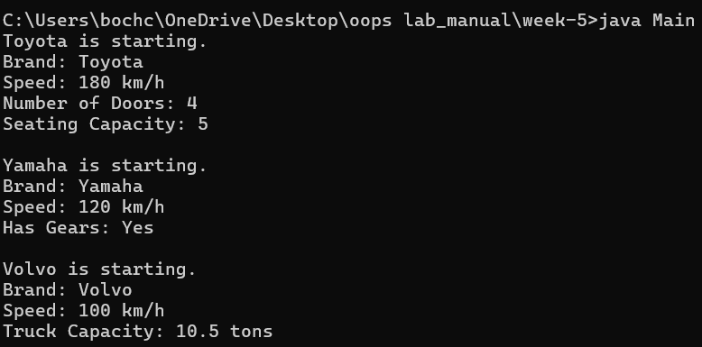

ERROR TABLE:

|  |  |  |
| --- | --- | --- |
| **S.NO** | **Errors** | **Rectification** |
| 1 | .variable | We must mention variable name to call the variable. |
| 2 | static | Static variables contain only one value. |

WEEK-6

1)Write a java program to create a vechiles class with a method displayinfo() override this method in the car subclass to provide specific information about a car

* Company
* Model
* Price
* Seating capacity
* Petrol or not

Program:

class Vehicle {

String Brand;

String model;

String fuel;

String color;

int capacity;

Vehicle(String Brand, String model, String fuel, int capacity, String color) {

this.Brand = Brand;

this.model = model;

this.fuel = fuel;

this.capacity = capacity;

this.color = color;

}

void displayInfo(String Brand, String model, String fuel, int capacity, String color) {

System.out.println("Vehicle Details: ");

System.out.println("Brand: " + Brand);

System.out.println("Model: " + model);

System.out.println("Fuel: " + fuel);

System.out.println("Capacity: " + capacity);

System.out.println("Color: " + color);

}

}

class Car extends Vehicle {

Car(String Brand, String model, String fuel, int capacity, String color) {

super(Brand, model, fuel, capacity, color);

}

void displayInfo() {

System.out.println("B.Tirumala Sai");

System.out.println("CSE-A");

System.out.println("Roll.NO:24028");

System.out.println("");

System.out.println("Car Details: ");

System.out.println("Brand: " + Brand);

System.out.println("Model: " + model);

System.out.println("Fuel: " + fuel);

System.out.println("Capacity: " + capacity);

System.out.println("Color: " + color);

}

}

class Week6_1 {

public static void main(String[] args) {

// Creating an instance of Car

Car car1 = new Car("toyata", "fortuner", "Petrol", 6, "Red");

car1.displayInfo();

}

}

**Output:**

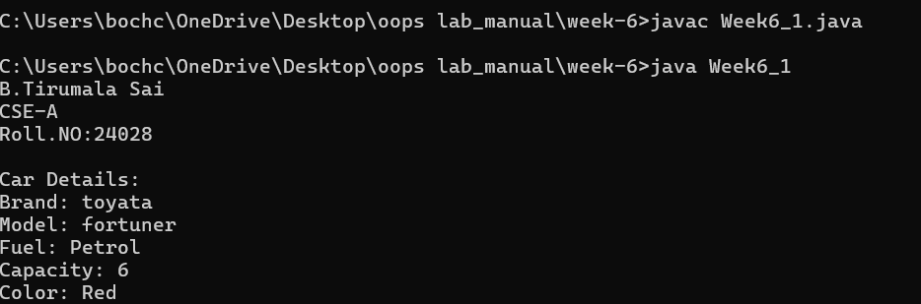

**CLASS DIAGRAM:**

|  |
| --- |
| **Vehicle** |
| **+display info():void** |

|  |
| --- |
| **Car** |
| **+displayinfo():void** |

**ERROR:**

|  |  |  |
| --- | --- | --- |
| s.no | Expected error | reason |
| 1. | Settingtheparametersinside the constructor | Wecannotpassthe valuesinsideconstructor without setting them first |
| 2. | } | Ending the class and main method is required |

2Q) A college is developing automated admission system that verifies students eligibility for UG and PG programs .Each program has different eligibility criteria based on the students percentage in their previous qualification.

* UG admission require minimum 60%
* PG admission require minimum 70%

**Program:**

import java.util.Scanner;

class College {

String name;

int qualification;

int percentage;

College(String name, int qualification, int percentage) {

this.name = name;

this.qualification = qualification;

this.percentage = percentage;

}

public void Eligibility() {

System.out.println("Name: " + name + ", Qualification: " + qualification + ", Percentage: " + percentage);

System.out.println("The candidate is a fluke");

}

}

class UG extends College {

UG(String name, int qualification, int percentage) {

super(name, qualification, percentage);

}

public void Eligibility() {

System.out.println("Name: " + name + ", Qualification: " + qualification + ", Percentage: " + percentage);

System.out.println("The candidate is eligible for UG");

}

}

class PG extends College {

PG(String name, int qualification, int percentage) {

super(name, qualification, percentage);

}

public void Eligibility() {

System.out.println("Name: " + name + ", Qualification: " + qualification + ", Percentage: " + percentage);

System.out.println("The candidate is eligible for PG");

}

}

public class Main {

public static void main(String[] args) {

Scanner input = new Scanner(System.in);

System.out.println("Enter your name:");

String name = input.nextLine();

System.out.println("Enter your qualification (e.g., 12 for high school, 10 for 10th, etc.):");

int qualification = input.nextInt();

System.out.println("Enter your percentage:");

int percentage = input.nextInt();

input.close();

College candidate;

if (percentage >= 70) {

candidate = new PG(name, qualification, percentage);

} else if (percentage >= 60) {

candidate = new UG(name, qualification, percentage);

} else {

candidate = new College(name, qualification, percentage);

}

candidate.Eligibility();

}

}

**Input:**

* **Name:E. B.Tirumala Sai**
* **Qualification: 12**
* **Percentage: 92**

**Output:**

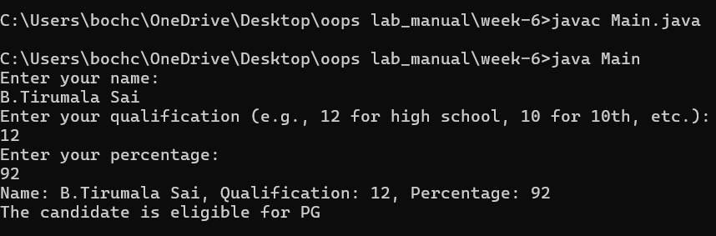

**CLASS DIAGRAM:**

|  |
| --- |
| **adm** |
| **elg():void** |

|  |  |
| --- | --- |
| **ug** | **pg** |
| **+elg():void** | **+elg():void** |
|  |  |

**ERROR:**

|  |  |  |
| --- | --- | --- |
|  | Expected Error | Reason |
| 1 | Setting the parameters inside the constructor | We cannot pass the values inside constructor without setting them first |
| 2 | } | Ending the class and main method is required |

**3Q)Create a calculator class with overloading methods to perform addition**

* **Add two doubles**
* **Add two integer**
* **Add three integer**

**Program:**

public class Calculator{

public int add(int a, int b) {

return a + b;

}

public int add(int[] tuple1, int[] tuple2) {

int sum = 0;

for (int i = 0; i < tuple1.length; i++) {

sum += tuple1[i] + tuple2[i];

}

return sum;

}

public int add(int a, int b, int c) {

return a + b + c;

}

public static void main(String[] args) {

Calculator calc = new Calculator();

int result1 = calc.add(10, 20);

System.out.println("Addition of two integers: " + result1);

int[] tuple1 = {1, 2};

int[] tuple2 = {3, 4};

int result2 = calc.add(tuple1, tuple2);

System.out.println("Addition of two tuples: " + result2);

int result3 = calc.add(5, 10, 15);

System.out.println("Addition of three integers: " + result3);

}

}

OUTPUT:

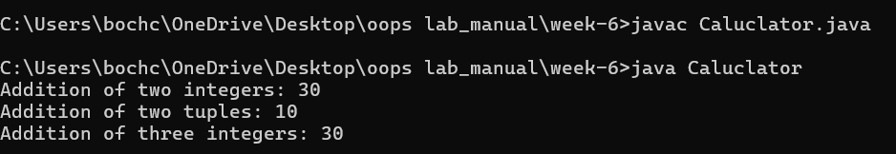

CLASS DIAGRAM:

|  |
| --- |
| **cacluator** |
| **+add(int a,int b):int**  **+add(double a,double b):double**  **+add(int a,int b,int c):int** |

**ERROR:**

|  |  |  |
| --- | --- | --- |
| S.No. | Expected Error | Reason |
| 1 | Setting the parameters inside the constructor | We cannot pass the values inside constructor without setting them first |
| 2 | } | Ending the class and main method is required |

4.Create a shape class with method calculateArea() that is overloaded for different shapes (eg: square, rectangle).Then create a subclass Circle that overrides calculateArea() method for Circle.

**CODE:**

class shape{

public float calarea(float side){ return side*side;

}

public float calarea(float l,float b){ return l*b;

}

}

class circle extends shape{

public double calarea(double r){ return 3.14*r*r;

}

}

class s{

public static void main(String[] args){ circle c=new circle(); System.out.println(c.calarea(10));

}

}

OUTPUT:

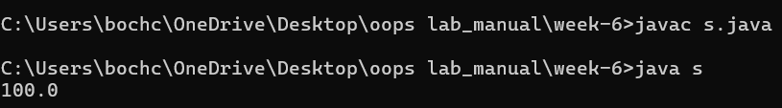

**CLASS DIAGRAM:**

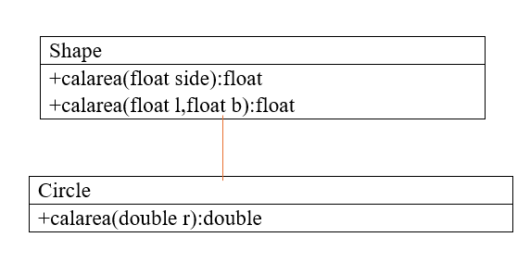

**ERRORS:**

|  |  |  |
| --- | --- | --- |
| **s.no** | **Expected error** | **reason** |
| **1.** | **Setting the parameters inside the constructor** | **We cannot pass the values inside constructor without setting them first** |
| **2.** | **}** | **Ending the class and main method is required** |

**Week-7**

**1Q)Write a java program to create an abstract class Animal with an abstract method sound().Create Subclass Tiger and Lion extends the Animal class and implement the sound() method to make a specific sound for each animal**

**Program:**

**abstract class Animal {**

**public abstract void sound();**

**}**

**class Lion extends Animal {**

**@Override**

**public void sound() {**

**System.out.println("Lion: Roar!");**

**}**

**}**

**class Tiger extends Animal {**

**public void sound() {**

**System.out.println("Tiger: Growl!");**

**}**

**}**

**public class Week7_1 {**

**public static void main(String[] args) {**

**Animal lion = new Lion();**

**Animal tiger = new Tiger();**

**lion.sound();**

**tiger.sound();**

**}**

**}**

**CLASS DIAGRAM**

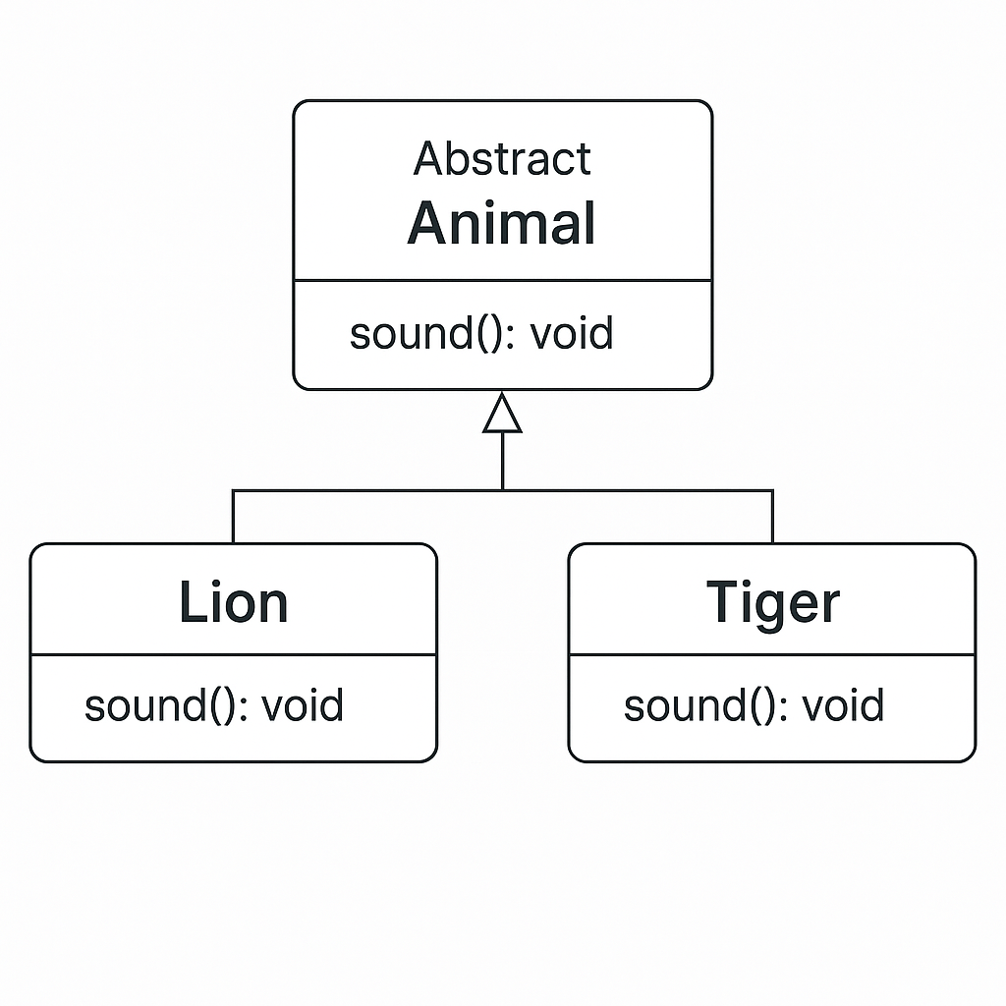

**Output:**

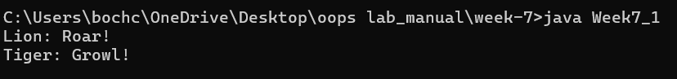

**Error Table:**

|  |  |  |
| --- | --- | --- |
| **S.no** | **Expected Error** | **Reason** |
| **1** | **Setting the parameters inside the constructor** | **We cannot pass the values inside constructor without setting them first** |
| **2** | **}** | **Ending the class and main method is required** |

**2Q)Write a java program to create an abstract class Shape3D with an abstract methods Calculate_volume() and Calculate_Surface_area.Create Subclass Sphere and Cube extends the Shape3D class and implement the respective methods to calculate the volume and surface_area of each shape.**

**Program:**

**abstract class Shape3D {**

**public abstract void calculate_volume();**

**public abstract void calculate_surf_a();**

**}**

**class Sphere extends Shape3D {**

**private double radius;**

**public Sphere(double radius) {**

**this.radius = radius;**

**}**

**public void calculate_surf_a() {**

**double surfaceArea = 4 * Math.PI * Math.pow(radius, 2);**

**System.out.printf("Surface Area of Sphere: %.2f%n", surfaceArea);**

**}**

**public void calculate_volume() {**

**double volume = (4.0 / 3) * Math.PI * Math.pow(radius, 3);**

**System.out.printf("Volume of Sphere: %.2f%n", volume);**

**}**

**}**

**class Cube extends Shape3D {**

**private double side;**

**public Cube(double side) {**

**this.side = side;**

**}**

**public void calculate_surf_a() {**

**double surfaceArea = 6 * Math.pow(side, 2);**

**System.out.printf("Surface Area of Cube: %.2f%n", surfaceArea);**

**}**

**public void calculate_volume() {**

**double volume = Math.pow(side, 3);**

**System.out.printf("Volume of Cube: %.2f%n", volume);**

**}**

**}**

**public class Week7_2 {**

**public static void main(String[] args) {**

**Shape3D sphere = new Sphere(5);**

**Shape3D cube = new Cube(3);**

**sphere.calculate_surf_a();**

**sphere.calculate_volume();**

**cube.calculate_surf_a();**

**cube.calculate_volume();**

**}**

**}**

**CLASS DIAGRAM:**

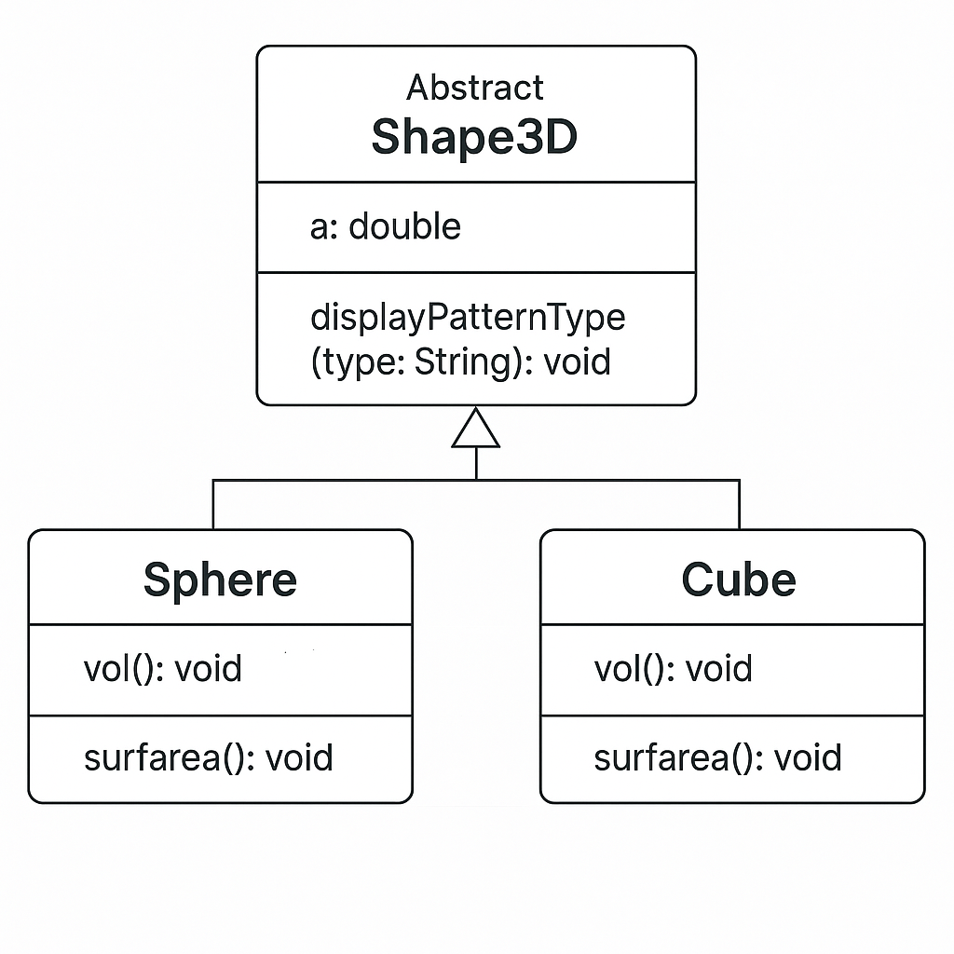

**Output:**

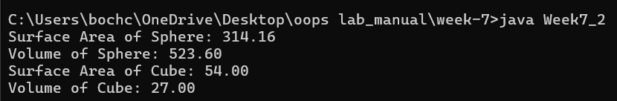

**Error Table:**

|  |  |  |
| --- | --- | --- |
| **S.no** | **Expected Error** | **Reason** |
| **1** | **Setting the parameters inside the constructor** | **We cannot pass the values inside constructor without setting them first** |
| **2** | **}** | **Ending the class and main method is required** |

**3Q)Write a java program using an abstract class to define a method for pattern printing**

**-->create an abstract class named patternprinting with an abstract method print pattern (int n) and a concrete method to display the pattern title**

**-->impletment two sub classes**

1. **star pattern**

**Prints a right angled triangle of stars**

1. **Number pattern**

**Prints a right angled triangle of increasing numbers**

**-->in the main()method create objects of both sub classes and print the patterns for a given number of rows**

**Program:**

**import java.util.Scanner;**

**abstract class Pattern {**

**public abstract void printPattern(int n);**

**}**

**class RightTrianglePattern extends Pattern {**

**public void printPattern(int n) {**

**System.out.println("Right Triangle Pattern:");**

**for (int i = 1; i <= n; i++) {**

**for (int j = 1; j <= i; j++) {**

**System.out.print("* ");**

**}**

**System.out.println();**

**}**

**}**

**}**

**class NumberPattern extends Pattern {**

**public void printPattern(int n) {**

**System.out.println("number pattern:");**

**for (int i =1; i <= n; i++) {**

**for (int j = 1; j <= i; j++) {**

**System.out.print( j);**

**}**

**System.out.println();**

**}**

**}**

**}**

**public class Week7_3 {**

**public static void main(String[] args) {**

**Scanner input= new Scanner(System.in);**

**System.out.println("enter the n value to select number of rows");**

**int n=input.nextInt();**

**Pattern rightTriangle = new RightTrianglePattern();**

**Pattern numberpattern = new NumberPattern();**

**rightTriangle.printPattern(n);**

**numberpattern.printPattern(n);**

**}**

**}**

**CLASS DIAGRAM:**

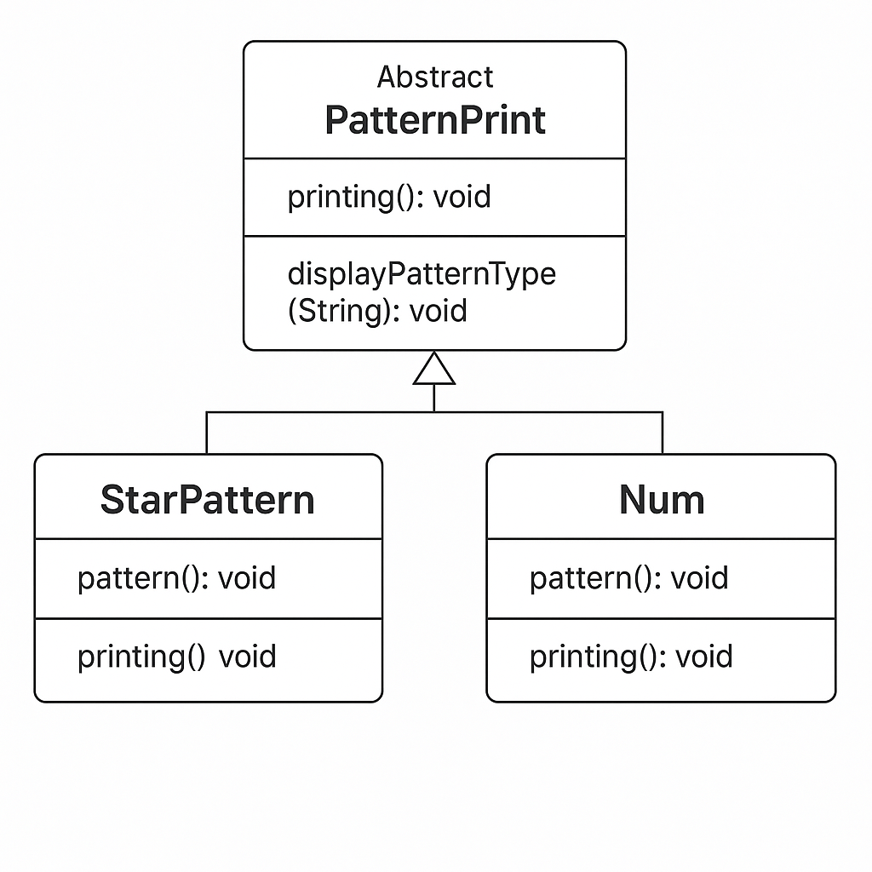

**Output:**

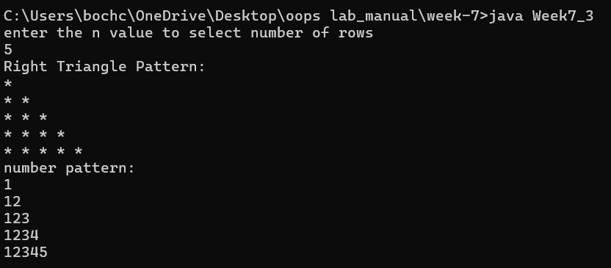

**Error Table:**

|  |  |  |
| --- | --- | --- |
| **S.no** | **Expected Error** | **Reason** |
| **1** | **Setting the parameters inside the constructor** | **We cannot pass the values inside constructor without setting them first** |
| **2** | **}** | **Ending the class and main method is required** |

**Week-8**

**Q)write a java program creating an interface Shape with the get perimeter method create 3 classes rectangle,triangleand circle that implements the shape interface ,implement the getperimeter method for each of the three classes**

**CODE:**

**import java.util.*;**

**public interface Shape {**

**abstract int getperimeter();**

**}**

**class rectangle implements Shape{**

**int len,bred;**

**rectangle(int len, int bred){**

**this.len=len;**

**this.bred=bred;}**

**public int getperimeter(){**

**return 2*(len+bred);**

**}**

**}**

**class triangle implements Shape{**

**int side1,side2,side3;**

**triangle(int side1, int side2, int side3){**

**this.side1=side1;**

**this.side2=side2;**

**this.side3=side3;}**

**public int getperimeter(){**

**return side1+side2+side3;**

**}**

**}**

**class Circle implements Shape{**

**double radius;**

**Circle(int radius){**

**this.radius=radius;}**

**public int getperimeter(){**

**return (int) (2 * Math.PI * radius);**

**}}**

**class Week8_1{**

**public static void main(String[] args){**

**Shape Rec= new rectangle(10,5);**

**Shape Tri=new triangle(10,10,10);**

**Shape circle= new Circle(10);**

**System.out.println("rect:"+Rec.getperimeter());**

**System.out.println("rect:"+Tri.getperimeter());**

**System.out.println("rect:"+ circle.getperimeter());**

**}**

**}**

**OUTPUT:**

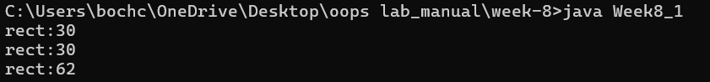

**Class Diagrams:**

|  |
| --- |
| **<interfaces>**  **Shape** |
| **+getperimeter():double** |

|  |
| --- |
| **Rectangle** |
| **-Width: int**  **-height: int** |
| **+getperimeter():Double** |

|  |
| --- |
| **Triangle** |
| **-side1:int**  **-side2:int**  **-side3:int** |
| **+getperimeter():double** |

|  |
| --- |
| **Circle** |
| **-radius:int** |
| **+getperimeter():double** |

**Error Table:**

|  |  |  |
| --- | --- | --- |
| **S.NO** | **Errors** | **Rectification** |
| **1** | **this.side3=side;** | **this.side3 = side3;** |
| **2** | **Shape circle = Circle(4);** | **Shapecircle =newCircle(4);** |

**2Q)write a java program to create an interface playable with a method play()**

**That takes no arguments and returns void create three classes football,volleyball and basketball that implements the playable and override the play method to play the respective sports**

**CODE:**

**import java.util.*;**

**interface Playable{**

**void Play();**

**}**

**class Volleyball implements Playable{**

**public void Play(){**

**System.out.println("playing vollyball");**

**}**

**}**

**class Football implements Playable{**

**public void Play(){**

**System.out.println("football");**

**}**

**}**

**class Basketball implements Playable {**

**public void Play() {**

**System.out.println("playing basketball");**

**}**

**}**

**class Week8_2 {**

**public static void main(String[] args){**

**Playable Volly= new Volleyball();**

**Playable foot= new Football();**

**Playable base= new Basketball();**

**Volly.Play();**

**foot.Play();**

**base.Play();**

**}**

**}**

**OUTPUT:**

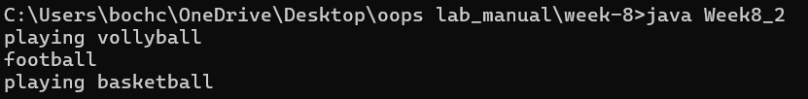

|  |
| --- |
| **<Interface>**  **Playable** |
| **+play():void** |

**CLASS DIAGRAM:**

|  |
| --- |
| **Basketball** |
| **+play():void** |

|  |
| --- |
| **Vollyball** |
| **+play():void** |

|  |
| --- |
| **Football** |
| **+play():void** |

**Error Table:**

|  |  |  |
| --- | --- | --- |
| **s.no** | **Expected Error** | **Reason** |
| **1** | **Settingteparameters inside the constructor** | **Wecannotpassthevalues inside constructor without setting them first** |
| **2** | **}** | **Ending the class and main method is required** |

**3Q)write a java program to implement a login system using interfaces**

**Program:**

**interface LoginSystem {**

**boolean login(String id, String password);**

**}**

**class UniversityPortal implements LoginSystem {**

**public boolean login(String id, String password) {**

**if (id.equals("student123") && password.equals("pass123")) {**

**return true;**

**} else {**

**System.out.println("Invalid credentials");**

**return false;**

**}**

**}**

**}**

**public class Week8_3 {**

**public static void main(String[] args) {**

**UniversityPortal portal = new UniversityPortal();**

**boolean loginSuccess1 = portal.login("student123", "pass123");**

**System.out.println("Login successful: " + loginSuccess1);**

**boolean loginSuccess2 = portal.login("student123", "wrong pass");**

**System.out.println("Login successful: " + loginSuccess2);**

**}**

**}**

**OUTPUT:**

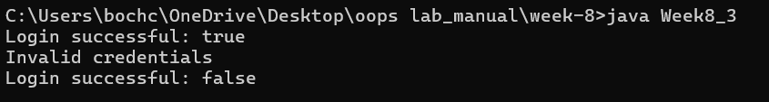

**Error Table:**

|  |  |  |
| --- | --- | --- |
| **S.no** | **Expected Error** | **Reason** |
| **1** | **Settingtheparameters inside the constructor** | **Wecannotpassthe valuesinsideconstructor without setting them first** |
| **2** | **}** | **Ending the class and main method is required** |